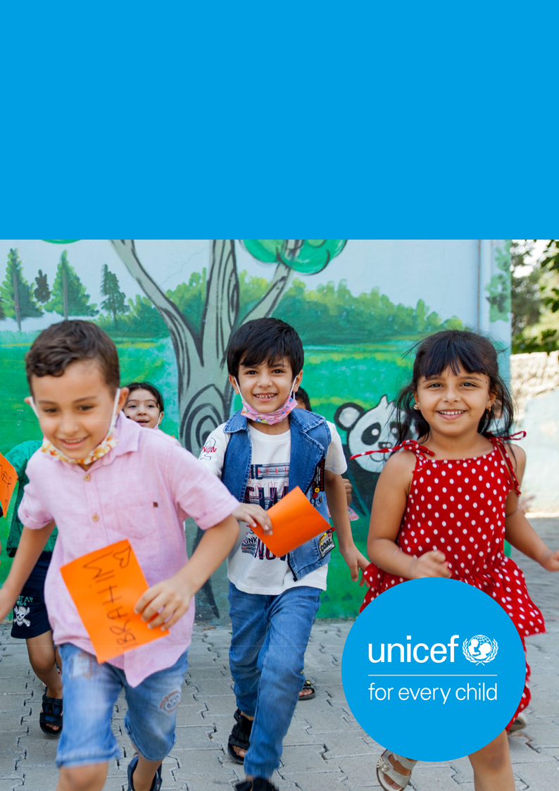

Europe and Central Asia Child Rights Monitoring Framework

*Domain and sub-domain descriptions (without indicators)*

Draft (vers. 1) for consultations – Jun 2023 UNICEF Regional Office for Europe and Central Asia



**This document is produced by the UNICEF Regional Office for Europe and Central Asia (ECARO).**

The statements in this publication are the views of the author(s) and do not necessarily reflect the policies or the views of UNICEF.

All images in this report are intended for informational purposes only and must be used only about this report and its content. All photos are used for illustrative purposes only. UNICEF photographs are copyrighted and may not be used for an individual’s or organization’s promotional activities or in any commercial context.

The content cannot be digitally altered to change meaning or context. All reproductions of non-brand content MUST be credited.

UNICEF Regional Office for Europe and Central Asia (ECARO) / TransMonEE

www.unicef.org/eca/

www.transmonee.org

ecarodata@unicef.org

© 2023 UNICEF. All rights reserved.

Contents

DOMAIN 1: CHILD RIGHTS LANDSCAPE AND GOVERNANCE 4

SUB-DOMAIN 1.1.: DEMOGRAPHICS 4

SUB-DOMAIN 1.2.: POLITICAL ECONOMY 5

SUB-DOMAIN 1.3.: CHILD RIGHTS GOVERNANCE 5

SUB-DOMAIN 1.4.: PUBLIC SPENDING ON CHILDREN 6

SUB-DOMAIN 1.5.: DATA ON CHILDREN 6

SUB-DOMAIN 1.6.: RIGHT TO REMEDY 6

SUB-DOMAIN 1.7.: BUSINESS AND CHILD RIGHTS 7

DOMAIN 2: HEALTH AND NUTRITION 8

SUB-DOMAIN 2.1.: HEALTH SYSTEM 8

SUB-DOMAIN 2.2.: MATERNAL, NEWBORN AND CHILD HEALTH 8

SUB-DOMAIN 2.3.: IMMUNIZATION 9

SUB-DOMAIN 2.4.: NUTRITION 9

SUB-DOMAIN 2.5.: ADOLESCENT PHYSICAL, MENTAL AND REPRODUCTIVE HEALTH 9

SUB-DOMAIN 2.6.: HIV/AIDS 10

DOMAIN 3: EDUCATION, LEISURE AND CULTURE 11

SUB-DOMAIN 3.1.: EDUCATION SYSTEM 11

SUB-DOMAIN 3.2.: EDUCATION ACCESS AND PARTICIPATION 11

SUB-DOMAIN 3.3.: LEARNING QUALITY AND SKILLS 12

SUB-DOMAIN 3.4.: LEISURE AND CULTURE 12

DOMAIN 4: FAMILY ENVIRONMENT AND PROTECTION FROM VIOLENCE AND HARMFUL PRACTICES 13

SUB-DOMAIN 4.1.: VIOLENCE AGAINST CHILDREN AND WOMEN 13

SUB-DOMAIN 4.2.: CHILDREN IN ALTERNATIVE CARE 14

SUB-DOMAIN 4.3.: JUSTICE FOR CHILDREN 14

SUB-DOMAIN 4.4.: CHILD MARRIAGE AND OTHER HARMFUL PRACTICES 15

SUB-DOMAIN 4.5.: CHILD EXPLOITATION 15

DOMAIN 5: PARTICIPATION AND CIVIL RIGHTS 16

SUB-DOMAIN 5.1.: BIRTH REGISTRATION AND IDENTITY 16

SUB-DOMAIN 5.2.: CHILD PARTICIPATION 17

SUB-DOMAIN 5.3.: CIVIL AND POLITICAL FREEDOMS 17

SUB-DOMAIN 5.4.: INFORMATION, INTERNET AND PROTECTION OF PRIVACY 17

DOMAIN 6: POVERTY AND ADEQUATE STANDARD OF LIVING 18

SUB-DOMAIN 6.1.: SOCIAL PROTECTION SYSTEM 18

SUB-DOMAIN 6.2.: CHILD POVERTY AND MATERIAL DEPRIVATION 18

SUB-DOMAIN 6.3.: WATER AND SANITATION 19

DOMAIN 7: CROSS-CUTTING 20

7.1.: GENDER 20

7.2.: DISABILITY 20

7.3.: EARLY CHILDHOOD DEVELOPMENT 21

7.4.: ADOLESCENTS 21

7.5.: ENVIRONMENT AND CLIMATE CHANGE 22

7.6.: DISASTER, CONFLICT AND DISPLACEMENT 23

Abbreviations

ARV antiretroviral

CI confidence interval

CRC Convention on the Rights of the Child

CRM child rights monitoring

DHS demographic and health surveys

DRR disaster risk reduction

EHIS European health interview survey

EPSR European pillar for social rights

EU-SILC EU statistics on income and living conditions

GATS global adult tobacco survey

GDP gross domestic product

GNI gross national income

GSHS global school-based student health survey

HBS household budget survey

HBSC health behaviour in school-aged children survey

ILO International Labour Organization

ISCED international standard classification of education

LFS labour force survey

LSMS living standard measurement study

MICS multiple indicator cluster survey

NHRI national human rights institution

ODA official development assistance

PISA programme for international student assessment

PMTCT prevention of mother to child transmission

PPP purchasing power parity

SDG sustainable development goals

WHO World Health Organization

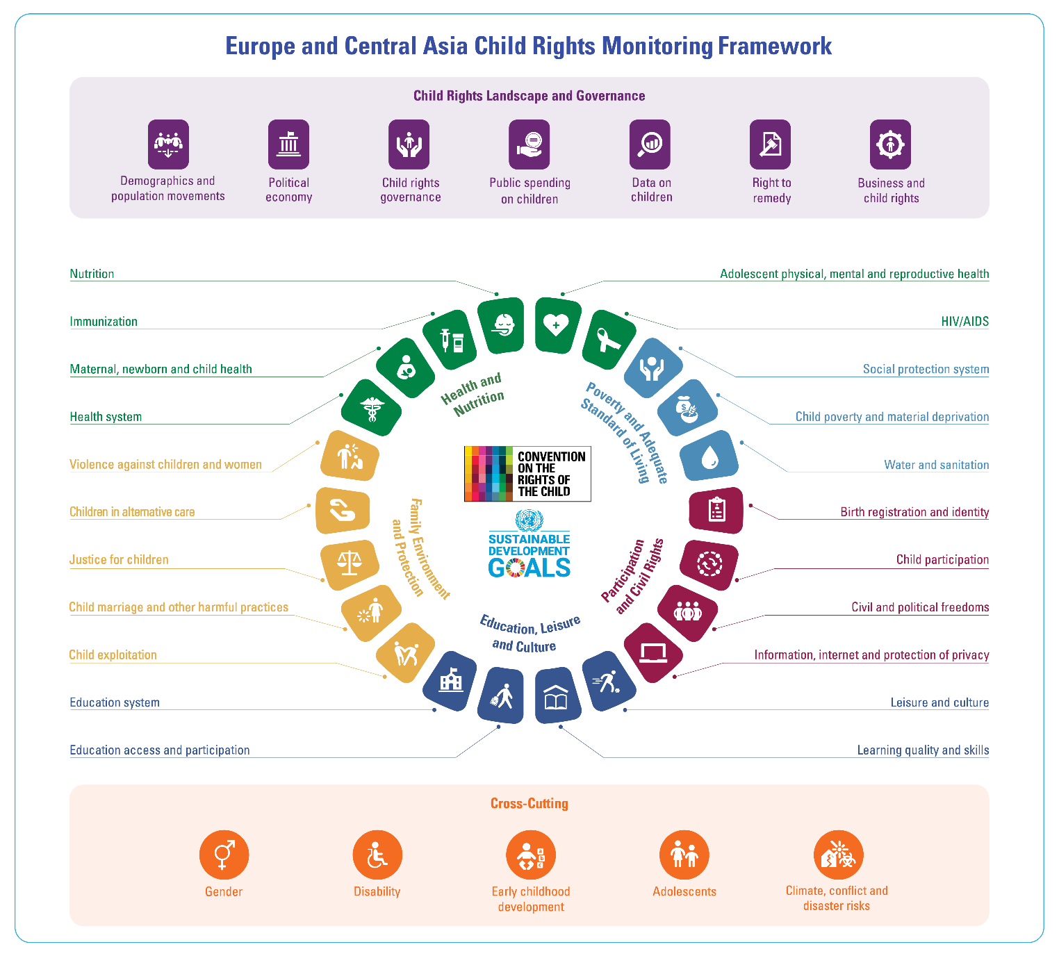**OVERVIEW OF THE FRAMEWORK**

The United Nations **Convention on the Rights of the Child** (CRC) is the leading international treaty on the child's rights, ratified by almost all members of the United Nations. Its provisions are detailed and comprehensive and cover many areas of children's lives, from family and health care to education and leisure, with provisions for particularly vulnerable children, like those in alternative care, children in situations of migration and children in contact with the law. In light of the indivisible and interdependent nature of its provisions, States Parties are required to implement the CRC as a whole, thus, ensuring the realisation and monitoring of all rights guaranteed under the treaty for all children in their jurisdiction.[1]

**Child rights monitoring** (CRM) may be described as "an effort to systematically evaluate the extent to which all the rights of all children are effectively protected and fulfilled."[2] Ensuring that the monitoring process addresses all the rights contained in the CRC and not only a specific group of rights is of key importance.[3] CRM requires a proactive approach to collecting data, ensuring its accuracy, reporting and use to further child rights.[4] It has several important purposes, including identification of the rights that are not adequately protected or enjoyed, and the groups of children that may be particularly disadvantaged, evaluation of the relevance and effectiveness of the measures that are in place to promote the safeguard child rights and fostering informed social debate on public policies concerning child rights.[5]

In the national and international contexts, there have been several initiatives for applying various frameworks and tools for monitoring child rights. They have been crucial in understanding child rights issues and supporting better public policy response and programme development. Nevertheless, the existing practices have often been limited in breadth and scope, as there are aspects of the CRC that are not sufficiently covered, while direct data and indicator linkages to the CRC provisions and the broader 2030 Agenda for Sustainable Development are frequently lacking. One of the frequent recommendations of the Committee on the Rights of the Child is developing a comprehensive data, analysis and monitoring system on children covering all areas of the Convention, in line with its General Comment No. 5 (2003). The Committee recommended this to many countries in the region in recent years.

While initially started with the attempt to organise situation analyses of child rights, the suggested **Child Rights Monitoring Framework** can help systematise the data, monitoring and analysis related to child rights across countries and regional actors. It strives to promote a holistic and coherent approach to child rights monitoring, having its conceptual roots in the CRC.

The framework focuses on **five critical child rights domains**, further broken into specific sub-domains. It also includes a domain of **Child Rights Landscape and Governance** (primarily covering the General Measures of Implementation of CRC) and **six cross-cutting dimensions or** **groups** which should be mainstreamed but require additional attention when monitoring is the case. Each sub-domain is mapped against the corresponding CRC article and, when applicable, to Sustainable Development Goal (SDGs) targets, acknowledging the interlinked nature of the child's rights and the 2030 Agenda for Sustainable Development. Suggested as a regional framework, it may have multiple applications and implications at the country level.

[**Sets of indicators** have been initially mapped](https://unicef.sharepoint.com/teams/ECAR-CHRTSMON/CRC%20monitoring/Forms/AllItems.aspx?id=%2Fteams%2FECAR%2DCHRTSMON%2FCRC%20monitoring%2FECA%20CRM%20framework%2FECA%20Child%20Rights%20Monitoring%20Framework%20and%20mapping%20of%20indicators%5FENG%5FDEC22%2Epdf&parent=%2Fteams%2FECAR%2DCHRTSMON%2FCRC%20monitoring%2FECA%20CRM%20framework) against each sub-domain but will require extensive discussions and refinement based on multiple consultations with all the key stakeholders. Existing measures and indicators are prioritised, starting with child-related SDG indicators and when applicable regional frameworks, such as the European Pillar of Social Rights (EPSR). The document also suggests desired levels of disaggregation (required in the case of SDG indicators), expected data source along the name of survey(s) where applicable, and a link to meta-data.

While the region is quite diverse, and the availability of data and data sources varies from one group of countries to another, this mapping represents an attempt to identify a core list of existing indicators for comprehensive monitoring of child rights across the region while highlighting critical data gaps and those child rights and sub-domains with no comparable or widely used measure, such as the right to remedy, leisure and participation. Depending on how well the measurements are developed for a particular sub-domain, it is marked using one of these categories: *well-developed measures* (green), *limited measures* (in yellow)or *no measures* (in red). A table at the end of the document summarizes these very initial and rough assessments, which by no means is about the availability of data, but about the availability of measures to meaningfully monitor child rights in that particular sub-domain.

Further refinements in this ambitious but useful work should consider factors such as potential data sources, representativeness, frequency of data collection, comparability, quality and disaggregation but most importantly, relevance.

## DOMAIN 1: CHILD RIGHTS LANDSCAPE AND GOVERNANCE

|  |  |  |
| --- | --- | --- |
| **DOMAIN DESCRIPTION** | **CRC ARTICLES** | [**SDGs**](https://unstats.un.org/sdgs/indicators/Global%20Indicator%20Framework%20after%20refinement_Eng.pdf) |
| Child Rights Landscape and Governance includes contextual indicators on political economy, demographics and the impact of businesses on the enjoyment of child rights. It also covers the general measures governments are required to undertake for the implementation of the CRC, such as the right to remedy, the availability and use of data on children and budgeting for the realisation of child rights. |  | SDG 8: Economic growth and decent work  Target 8.5    SDG 10: Reduce inequality  Target 10.3; 10.7.  SDG 16: Peace, justice and strong institutions  Targets: 16.3; 16.6; 16.a.  SDG 17: Partnerships for the goals  Targets: 17.1; 17.18; 17.17; 17.19 |
| **LINKS TO OTHER FRAMEWORKS** | | |
| [The EU Strategy on the Rights of the Child: Thematic area (4) Child-friendly justice](https://commission.europa.eu/system/files/2021-09/ds0821040enn_002.pdf)  [The EU Strategy on the Rights of the Child: Thematic area (6) Global dimension](https://commission.europa.eu/system/files/2021-09/ds0821040enn_002.pdf) | | |

### 

### **SUB-DOMAIN 1.1.: DEMOGRAPHICS**

|  |  |
| --- | --- |
| **SUB-DOMAIN DESCRIPTION** | **CRC ARTICLES** |
| Demographics provides an overview of a set of population and vital statistics, allowing for analysis of the basic demographic characteristics and phenomena on a national level, focusing on children. |  |

**DOMAIN 1: CHILD RIGHTS LANDSCAPE AND GOVERNANCE**

### **SUB-DOMAIN 1.2.: POLITICAL ECONOMY**

|  |  |
| --- | --- |
| **SUB-DOMAIN DESCRIPTION** | **CRC ARTICLES** |
| Political economy captures key drivers of the macro-level political, economic and social policy contexts. It includes indicators related to economic management and performance, structural policies, policies for social inclusion/equity, and public sector management and institutions. These indicators aim to foster a better understanding of the diverse structural factors which indirectly affect the enjoyment of child rights. |  |

**DOMAIN 1: CHILD RIGHTS LANDSCAPE AND GOVERNANCE**

### **SUB-DOMAIN 1.3.: CHILD RIGHTS GOVERNANCE**

|  |  |
| --- | --- |
| **SUB-DOMAIN DESCRIPTION** | **CRC ARTICLES** |
| Child rights governance covers multiple aspects related to the legislative, administrative, and other measures governments are required to undertake for the implementation of child rights. These include:   * measures for reviewing and bringing domestic legislation, policy and practice into full conformity with the CRC; * adopting and implementing a unifying, comprehensive and rights-based national strategy for children; * establishing cross-sectoral governmental structures for coordination and monitoring of child rights; * developing training and capacity-building for all those working with and for children; * measures for making the principles and provisions of the CRC widely known to adults and children; and * cooperating with civil society, including non-governmental organisations, child- and youth-led organisations and youth groups, parent and family groups, faith groups, academic institutions and professional associations. |  |

**DOMAIN 1: CHILD RIGHTS LANDSCAPE AND GOVERNANCE**

### **SUB-DOMAIN 1.4.: PUBLIC SPENDING ON CHILDREN**

|  |  |
| --- | --- |
| **SUB-DOMAIN DESCRIPTION** | **CRC ARTICLES** |
| Public spending on children concerns the management of financial resources that directly or indirectly affect children. It focuses on whether sufficient financial resources are being mobilised, allocated and spent in an accountable, effective, efficient, equitable, participatory, transparent and sustainable manner that facilitates the full realisation of child rights. |  |

**DOMAIN 1: CHILD RIGHTS LANDSCAPE AND GOVERNANCE**

### **SUB-DOMAIN 1.5.: DATA ON CHILDREN**

|  |  |
| --- | --- |
| **SUB-DOMAIN DESCRIPTION** | **CRC ARTICLES** |
| Data on children concerns the collection of sufficient, reliable and disaggregated data and evidence on children. It focuses on the effectiveness of the data collection systems, as well as on the evaluation and use of data to assess progress in implementation, to identify problems and to inform all policy development for children. |  |

**DOMAIN 1: CHILD RIGHTS LANDSCAPE AND GOVERNANCE**

### **SUB-DOMAIN 1.6.: RIGHT TO REMEDY**

|  |  |
| --- | --- |
| **SUB-DOMAIN DESCRIPTION** | **CRC ARTICLES** |
| Right to remedy refers to the general ability of children to obtain a remedy when their rights are being violated, not respected or denied. This can apply to children who are unable to access services like education, health care or social welfare to which they are entitled and children who are directly or indirectly part of legal or administrative proceedings that affect them. It entails aspects related to access to child-sensitive redress mechanisms, including before independent national human rights institutions. |  |

**DOMAIN 1: CHILD RIGHTS LANDSCAPE AND GOVERNANCE**

### **SUB-DOMAIN 1.7.: BUSINESS AND CHILD RIGHTS**

|  |  |
| --- | --- |
| **SUB-DOMAIN DESCRIPTION** | **CRC ARTICLES** |
| Business and child rights assesses the extent to which the business culture respects and supports child rights. It is particularly focused on the sufficiency and effectiveness on the legal and institutional frameworks which ensure that business enterprises identify, prevent and mitigate their impact on child rights, including across any business relationships linked to their operations, products or services and across their global operations. |  |

## 

## DOMAIN 2: HEALTH AND NUTRITION

|  |  |  |
| --- | --- | --- |
| **DOMAIN DESCRIPTION** | **CRC ARTICLES** | **SDGs** |
| The Health and Nutrition domain entails issues with respect to the overall health system and health services, prevalent health challenges to promoting the physical and mental health of mothers, newborns and children and specifically adolescents' physical, mental and reproductive health. It incorporates aspects related to immunisation coverage, nutrition, and prevention of HIV/AIDS. |  | SDG 2: Zero hunger  Targets 2.1; 2.2.  SDG 3: Good health and wellbeing  Targets: 3.1; 3.2; 3.3; 3.5; 3.7; 3.8; 3.a; 3.b.    SDG 5: Gender equality  Target 5.6 |
| **LINKS TO OTHER FRAMEWORKS** | | |
| [The EU Strategy on the Rights of the Child: Thematic area (2) Socio-economic inclusion, health and education](https://commission.europa.eu/system/files/2021-09/ds0821040enn_002.pdf) | | |

**SUB-DOMAIN 2.1.: HEALTH SYSTEM**

|  |  |
| --- | --- |
| **SUB-DOMAIN DESCRIPTION** | **CRC ARTICLES** |
| Health system is related to children's access to quality health services, including prevention, health promotion, care and treatment services. |  |

**DOMAIN 2: HEALTH AND NUTRITION**

### **Icon Description automatically generatedS****UB-DOMAIN 2.2.: MATERNAL, NEWBORN AND CHILD HEALTH**

|  |  |
| --- | --- |
| **SUB-DOMAIN DESCRIPTION** | **CRC ARTICLES** |
| Maternal, newborn and child health concerns the extent to which mothers, new-borns and children enjoy the highest attainable standard of health. |  |

**DOMAIN 2: HEALTH AND NUTRITION**

**S****UB-DOMAIN 2.3.: IMMUNIZATION**

|  |  |
| --- | --- |
| **SUB-DOMAIN DESCRIPTION** | **CRC ARTICLES** |
| Immunization reflects the progress and challenges with sustaining and advancing immunization coverage of children. |  |

**DOMAIN 2: HEALTH AND NUTRITION**

**S****UB-DOMAIN 2.4.: NUTRITION**

|  |  |
| --- | --- |
| **SUB-DOMAIN DESCRIPTION** | **CRC ARTICLES** |
| Nutrition captures children's access to nutritious, safe, affordable and sustainable diets. It covers breastfeeding practices and the prevalence of different forms of malnutrition, including undernutrition, hidden hunger and overweight. |  |

**DOMAIN 2: HEALTH AND NUTRITION**

|  |  |
| --- | --- |
| **SUB-DOMAIN DESCRIPTION** | **CRC ARTICLES** |
| Adolescent physical, mental and reproductive health focuses on the specific health and development needs, outcomes and challenges among adolescents and their access to quality, well-coordinated and well-integrated programs and services. |  |

### **Icon Description automatically generatedSU****B-DOMAIN 2.5.: ADOLESCENT PHYSICAL, MENTAL AND REPRODUCTIVE HEALTH**

**DOMAIN 2: HEALTH AND NUTRITION**

### **Icon Description automatically generatedSUB-DOMAIN 2.6.: HIV/AIDS**

|  |  |
| --- | --- |
| **SUB-DOMAIN DESCRIPTION** | **CRC ARTICLES** |
| HIV/AIDS concerns the prevalence, prevention and treatment of HIV/AIDS infections among children. |  |

## 

## DOMAIN 3: EDUCATION, LEISURE AND CULTURE

|  |  |  |
| --- | --- | --- |
| **DOMAIN DESCRIPTION** | **CRC ARTICLES** | **SDGs** |
| The Education, Leisure and Culture domain embraces multiple dimensions inherent to the right to education, with reference to children's access to and participation in the different stages of the educational process, the quality of education, as well as the key strengths and bottlenecks of the education system itself. It also covers children's access to their rights to rest, play, leisure, recreation, and cultural and artistic activities. |  | C:\Users\Goran\AppData\Local\Microsoft\Windows\INetCache\Content.Word\E-WEB-Goal-04.pngSDG 4: Quality education  Targets: 4.1; 4.2; 4.4; 4.5; 4.6; 4.7; 4.a; 4.c.    SDG 8: Economic growth and decent work  Target 8.6 |
| **LINKS TO OTHER FRAMEWORKS** | | |
| [The EU Strategy on the Rights of the Child: Thematic area (2) Socio-economic inclusion, health and education](https://commission.europa.eu/system/files/2021-09/ds0821040enn_002.pdf) | | |

|  |  |
| --- | --- |
| **SUB-DOMAIN DESCRIPTION** | **CRC ARTICLES** |
| Education system covers a range of context, input and process-related dimensions. These include key structural characteristics of education systems, policy frameworks and application of standards, deployment and use of financial, material, and human resources to facilitate learning, learning environment and climate, and broader social contexts in which educational institutions operate. |  |

### **Icon Description automatically generatedSUB-DOMAIN 3.1.: EDUCATION SYSTEM**

**DOMAIN 3: EDUCATION, LEISURE AND CULTURE**

### **Icon Description automatically generatedSUB-DOMAIN 3.2.: EDUCATION ACCESS AND PARTICIPATION**

|  |  |
| --- | --- |
| **SUB-DOMAIN DESCRIPTION** | **CRC ARTICLES** |
| Education access and participation is related to several aspects of accessibility to educational opportunities, including, physical accessibility, economic accessibility and non-discrimination (ensuring that education is accessible to all, especially the most vulnerable children). It also extends to the arrangements in place and practices to maintain regular school attendance and reduce drop-out rates. |  |

**DOMAIN 3: EDUCATION, LEISURE AND CULTURE**

|  |  |
| --- | --- |
| **SUB-DOMAIN DESCRIPTION** | **CRC ARTICLES** |
| Learning quality and skills concerns the educational outcomes and the extent to which education is child-centred, child-friendly and empowering. 'Educational outcomes' in this context goes far beyond academic achievements to embrace the broad range of physical, mental, social and emotional development of children, life competences and values that education should nurture. |  |

### **Icon Description automatically generatedSUB-DOMAIN 3.3.: LEARNING QUALITY AND SKILLS**

**DOMAIN 3: EDUCATION, LEISURE AND CULTURE**

### **Icon Description automatically generatedSUB-DOMAIN 3.4.: LEISURE AND CULTURE**

|  |  |
| --- | --- |
| **SUB-DOMAIN DESCRIPTION** | **CRC ARTICLES** |
| Leisure and culture capture the opportunities for children to engage in play, leisure, sports, cultural and artistic activities, and exercise their right to rest. It incorporates aspects related to safety, accessibility and quality of such opportunities in a diversity of settings. |  |

## DOMAIN 4: FAMILY ENVIRONMENT AND PROTECTION FROM VIOLENCE AND HARMFUL PRACTICES

|  |  |  |
| --- | --- | --- |
| **DOMAIN DESCRIPTION** | **CRC ARTICLES** | **SDGs** |
| The Family Environment and Protection domain spans several interrelated themes, such as children in alternative care and adoption, administration of justice for children, violence against children and women , child marriage and other harmful practices as well as child labour and other forms of exploitation. |  | SDG 5: Gender equality  Targets: 5.2; 5.3.  SDG 8: Economic growth and decent work  Target 8.7  SDG 16: Peace, justice and strong institutions  Targets 16.1; 16.2; 16.3. |
| **LINKS TO OTHER FRAMEWORKS** | | |
| [The EU Strategy on the Rights of the Child: Thematic area (3) Combatting violence against children and ensuring child protection](https://commission.europa.eu/system/files/2021-09/ds0821040enn_002.pdf) | | |

### **Icon Description automatically generatedSUB-DOMAIN 4.1.: VIOLENCE AGAINST CHILDREN AND WOMEN**

|  |  |
| --- | --- |
| **SUB-DOMAIN DESCRIPTION** | **CRC ARTICLES** |
| Violence against children and women captures the prevalence and the measures to prohibit, prevent and eliminate all forms of violence, such as physical or mental violence, injury or abuse, maltreatment, neglect or negligent treatment, including sexual abuse. |  |

**DOMAIN 4: FAMILY ENVIRONMENT AND PROTECTION**

### **Icon Description automatically generatedSUB-DOMAIN 4.2.: CHILDREN IN ALTERNATIVE CARE**

|  |  |
| --- | --- |
| **SUB-DOMAIN DESCRIPTION** | **CRC ARTICLES** |
| Children in alternative care concerns the protection of and assistance to children who are temporarily or permanently deprived of their family environment. It captures the arrangements in place and the practices for ensuring and maintaining the quality of alternative care. |  |

**DOMAIN 4: FAMILY ENVIRONMENT AND PROTECTION**

### **Icon Description automatically generatedSUB-DOMAIN 4.3.: JUSTICE FOR CHILDREN**

|  |  |
| --- | --- |
| **SUB-DOMAIN DESCRIPTION** | **CRC ARTICLES** |
| Justice for children concerns the rights of children in contact with the justice system as victims, witnesses and perpetrators. It captures aspects related to setting up of comprehensive policy and the undertaking of measures to prevent children from coming into contact with the law, strengthening child-friendly and sensitive procedures for children, quality and provision of non-custodial and diversion measures, provision of recovery and reintegration services, and strengthening of the systems through improved organisation, capacity-building, data collection, evaluation and research, among other. |  |

**DOMAIN 4: FAMILY ENVIRONMENT AND PROTECTION**

### **Icon Description automatically generatedSUB-DOMAIN 4.4.: CHILD MARRIAGE AND OTHER HARMFUL PRACTICES**

|  |  |
| --- | --- |
| **SUB-DOMAIN DESCRIPTION** | **CRC ARTICLES** |
| Child marriage and other harmful practices focuses specifically on the prevalence and measures to prohibit, prevent and eliminate all forms of harmful practices, which are deeply rooted in social conventions and social norms. Harmful practices include, but are not limited to female genital mutilation, violent and degrading initiation rites, "honour" crimes, forced marriage and early marriage. |  |

**DOMAIN 4: FAMILY ENVIRONMENT AND PROTECTION**

### **Icon Description automatically generatedSUB-DOMAIN 4.5.: CHILD EXPLOITATION**

|  |  |
| --- | --- |
| **SUB-DOMAIN DESCRIPTION** | **CRC ARTICLES** |
| Child exploitation concerns children in situations of economic exploitation, trafficking and sale, including measures to prohibit, prevent and eliminate and measures for children's physical and psychological recovery and social reintegration. |  |

## DOMAIN 5: PARTICIPATION AND CIVIL RIGHTS

|  |  |  |
| --- | --- | --- |
| **DOMAIN DESCRIPTION** | **CRC ARTICLES** | **SDGs** |
| Participation and Civil Rights incorporates issues that are part of the broader group of civil rights and freedoms, such as the right to birth registration, a name and nationality and the right to preservation of identity. Further to these, this domain includes elements relevant to child right to participation in individual and collective decision-making, access to information and protection of privacy, as well as civil and political freedoms, such as the freedom of expression, freedom of thought, conscience and religion and freedom of association. |  | C:\Users\Goran\AppData\Local\Microsoft\Windows\INetCache\Content.Word\E-WEB-Goal-04.pngSDG 4: Quality education  Target 4.4  A picture containing diagram  Description automatically generatedSDG 5: Gender equality  Targets 5.b  SGD 10: Reduced inequalities  Target 10.2  SGD 16: Peace, justice, and strong Institutions  Targets: 16.7; 16.9; 16.10.    SDG 17: Partnerships for the goals  Targets: 17.8; 17.19. |
| **LINKS TO OTHER FRAMEWORKS** | | |
| [The EU Strategy on the Rights of the Child: Thematic area (1) Child participation in political and democratic life](https://commission.europa.eu/system/files/2021-09/ds0821040enn_002.pdf)  [The EU Strategy on the Rights of the Child: Thematic area (5) Digital and information society](https://commission.europa.eu/system/files/2021-09/ds0821040enn_002.pdf) | | |

### **SUB-DOMAIN 5.1.: BIRTH REGISTRATION AND IDENTITY**

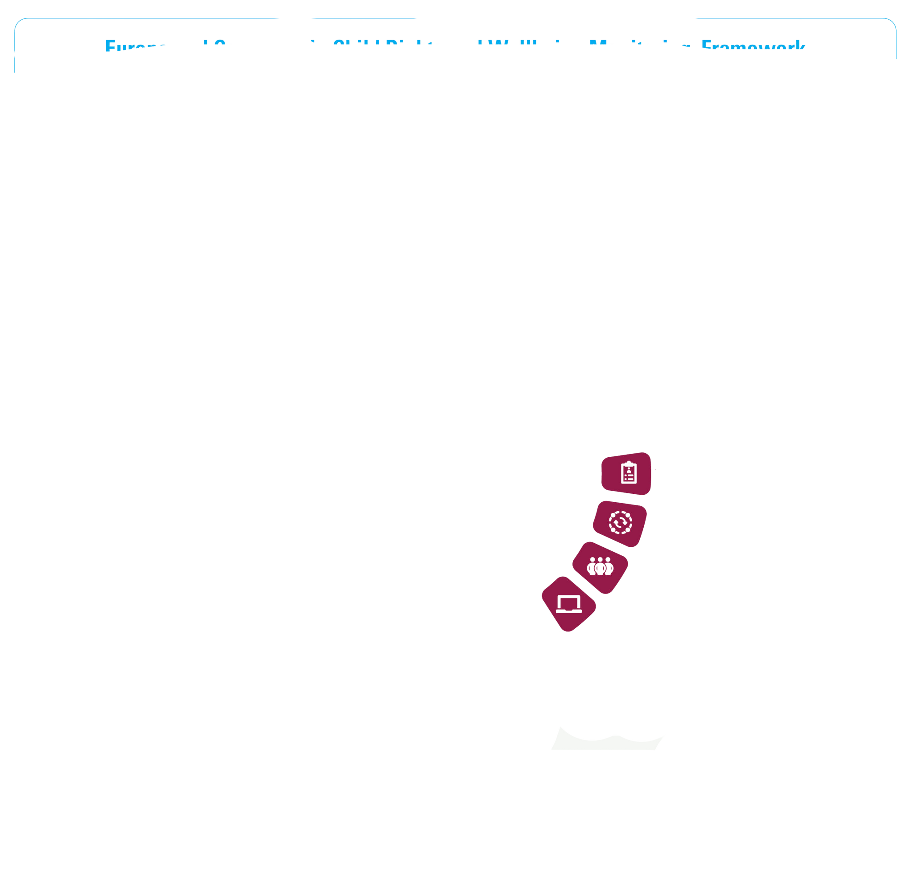

|  |  |
| --- | --- |
| **SUB-DOMAIN DESCRIPTION** | **CRC ARTICLES** |
| Birth registration and identity is related to the arrangements in place and the consistency of the practices of children's registration and naming immediately after birth, securing children's nationality and preventing statelessness, as well as preserving children's identity, including their nationality, name and family relations. |  |

**DOMAIN 5: PARTICIPATION AND CIVIL RIGHTS**

### **SUB-DOMAIN 5.2.: CHILD PARTICIPATION**



|  |  |
| --- | --- |
| **SUB-DOMAIN DESCRIPTION** | **CRC ARTICLES** |
| Child participation refers to the extent to which children enjoy their right to be heard and accorded due weight on matters affecting them in the diverse settings and situations in which they grow up, develop and learn. Such settings include, but are not limited to, family, alternative care, health care, education, play, recreation, sports and cultural activities, workplaces, emergency situations, situations of violence and immigration and asylum proceedings. Child participation captures both the right to be heard of an individual child and the right to be heard as applied to a group of children. |  |

**DOMAIN 5: PARTICIPATION AND CIVIL RIGHTS**

### **SUB-DOMAIN 5.3.: CIVIL AND POLITICAL FREEDOMS**



|  |  |
| --- | --- |
| **SUB-DOMAIN DESCRIPTION** | **CRC ARTICLES** |
| The Civil and political freedoms sub-domain relates to the opportunities for children's democratic engagement and promoting children as active, participating members of society. These include opportunities for children to enjoy the freedom to hold and express opinions through any media, the freedom of thought, conscience and religion, as well as the freedom of association and of peaceful assembly. |  |

**DOMAIN 5: PARTICIPATION AND CIVIL RIGHTS**

### **Icon Description automatically generatedSUB-DOMAIN 5.4.: INFORMATION, INTERNET AND PROTECTION OF PRIVACY**

|  |  |
| --- | --- |
| **SUB-DOMAIN DESCRIPTION** | **CRC ARTICLES** |
| Information, internet and protection of privacy concerns children's access to a wide diversity of child-sensitive and age-appropriate information and children's protection from arbitrary or unlawful interference with their privacy. The indicators included take into account the constantly evolving and expanding role of the digital environment in facilitating children's access to information and the threats to children's privacy arising from their increasing presence in the digital environment. |  |

## DOMAIN 6: POVERTY AND ADEQUATE STANDARD OF LIVING

|  |  |  |
| --- | --- | --- |
| **DOMAIN DESCRIPTION** | **CRC ARTICLES** | **SDGs** |
| Poverty and Adequate Standard of Living is dedicated on children's standard of living, including access to safe drinking-water, sanitation and hygiene, social security and social benefits, material assistance and support programmes. |  | SDG 1: Zero poverty  Targets: 1.1; 1.2; 1.3; 1.5; 1.b.  SGD 6: Clean Water and Sanitation  Targets: 6.1; 6.2; 6.b.  SDG 7: Affordable and clean energy  Target 7.1  SDG 11: Sustainable cities and communities  Targets: 11.1; 11.2; 11.7. |
| **LINKS TO OTHER FRAMEWORKS** | | |
| [The EU Strategy on the Rights of the Child: Thematic area (2) Socio-economic inclusion, health and education](https://commission.europa.eu/system/files/2021-09/ds0821040enn_002.pdf) | | |

### **SUB-DOMAIN 6.1.: SOCIAL PROTECTION SYSTEM**

|  |  |
| --- | --- |
| **SUB-DOMAIN DESCRIPTION** | **CRC ARTICLES** |
| Social protection system covers the availability, accessibility and quality of the social protection system, including social security benefits, childcare services and other forms of support for children and their families. |  |

**DOMAIN 6: POVERTY AND ADEQUATE STANDARD OF LIVING**

### **Logo, icon Description automatically generatedSUB-DOMAIN 6.2.: CHILD POVERTY AND MATERIAL DEPRIVATION**

|  |  |
| --- | --- |
| **SUB-DOMAIN DESCRIPTION** | **CRC ARTICLES** |
| Child poverty and material deprivation concerns the opportunities for children to enjoy an adequate standard of living which ensures their physical, mental, spiritual, moral and social development. It asses the effectiveness of the material assistance and support programmes aimed at reducing poverty and inequality, particularly with regard to nutrition, clothing and housing. |  |

**DOMAIN 6: POVERTY AND ADEQUATE STANDARD OF LIVING**

|  |  |
| --- | --- |
| **SUB-DOMAIN DESCRIPTION** | **CRC ARTICLES** |
| Water and sanitation assesses children's access to clean water, reliable sanitation and basic hygiene practices, and the measures in place for improving the infrastructure and expanding the services to those in need. |  |

### **Icon Description automatically generatedSUB-DOMAIN 6.3.: WATER AND SANITATION**

## 

## DOMAIN 7: CROSS-CUTTING

|  |  |  |
| --- | --- | --- |
| **DESCRIPTION** | **CRC ARTICLES** | **SDGs** |
| Gender address gender-specific discrimination and disadvantages that impede children’s access to and enjoyment of their rights. |  | A picture containing diagram  Description automatically generatedSDG 5: Gender equality  Targets: 5.1; 5.c |

### **Icon Description automatically generated7.1.: GENDER**

**DOMAIN 7: CROSS-CUTTING**

### **7.2.: DISABILITY**

|  |  |  |
| --- | --- | --- |
| **DESCRIPTION** | **CRC ARTICLES** | **SDGs** |
| Disability concerns the extent to which children with disabilities enjoy their rights, including access to all kinds of services, transportation and institutions, and in particular to education and cultural activities. |  | C:\Users\Goran\AppData\Local\Microsoft\Windows\INetCache\Content.Word\E-WEB-Goal-04.pngSDG 4: Quality education  Targets 4.5; 4.a.  SDG 8: Decent work and economic growth  Target 8.5    SDG 10: Reduced inequalities  Target 10.2  SDG 11: Sustainable cities and communities  Targets: 11.2, 11.7. |

**DOMAIN 7: CROSS-CUTTING**

### **7.3.: EARLY CHILDHOOD DEVELOPMENT**

|  |  |  |
| --- | --- | --- |
| **DESCRIPTION** | **CRC ARTICLES** | **SDGs** |
| Early childhood development concerns young children’s particular capacities, vulnerabilities and requirements for protection from harm and a sense of security, health care and nutrition, emotional care and responsive caregiving, as well as opportunities for early learning, play and exploration. |  | Icon  Description automatically generatedSDG 2: Zero hunger  Target 2.2  A green sign with white text  Description automatically generated with low confidenceSDG 3: Good health and well-being  Target 3.2  C:\Users\Goran\AppData\Local\Microsoft\Windows\INetCache\Content.Word\E-WEB-Goal-04.pngSDG 4: Quality education  Target 4.2 |

**DOMAIN 7: CROSS-CUTTING**

### **7.4.: ADOLESCENTS**

|  |  |  |
| --- | --- | --- |
| **DESCRIPTION** | **CRC ARTICLES** | **SDGs** |
| Adolescents focuses on the holistic adolescent development, as well as the opportunities and challenges pertinent to this critical period of transition from childhood to adulthood. |  | C:\Users\Goran\AppData\Local\Microsoft\Windows\INetCache\Content.Word\E-WEB-Goal-04.pngSDG 4: Quality education  Targets: 4.3, 4.4, 4.6, 4.b  SDG 8: Decent work and economic growth  Targets: 8.5, 8.6, 8.7, 8.b  SDG 3: Good health and wellbeing  Targets: 3.5, 3.7, 3.a    SDG 2: Zero hunger  Target 2.2  SDG 13: Climate action  Target 13.a |

**DOMAIN 7: CROSS-CUTTING**

### **7.5.: ENVIRONMENT AND CLIMATE CHANGE**

|  |  |  |
| --- | --- | --- |
| **DESCRIPTION** | **CRC ARTICLES** | **SDGs** |
| Environment and climate change covers issues such as access to a clean, healthy and sustainable environment and taking action to fight climate change. |  | SDG 1: No poverty  Target 1.5  SDG 3: Good health and wellbeing  Target 3.9  SDG 7: Affordable and clean energy (all targets)  SDG 11: Sustainable cities and communities  Target 11.5  SDG 12: Responsible consumption and production (all targets)  SGD 13: Climate action (all targets)  SDG 14: Life below water (all targets)  SDG 15: Life on land (all targets) |

**DOMAIN 7: CROSS-CUTTING**

### **7.6.: DISASTER, CONFLICT AND DISPLACEMENT**

|  |  |  |
| --- | --- | --- |
| **DESCRIPTION** | **CRC ARTICLES** | **SDGs** |
| Disaster, conflict and displacement addresses the right to protection during conflicts, natural disasters and other humanitarian emergencies. In addition, it focuses on children affected by migration and displacement and the extent to which they receive appropriate protection and humanitarian assistance in the enjoyment of their rights. |  | SDG 1: No poverty  Target 1.5    SDG 10: Reduce inequality  Target 10.7  SGD 13: Climate action  Target 13.1  SDG 16: Peace, justice and strong institutions  Targets: 16.1, 16.4; 16.8.  SDG 17: Partnerships for the goals  Targets: 17.2; 17.3. |

1. Committee on the Rights of the Child, [General Comment No 5, General measures of implementation of the Convention on the Rights of the Child](https://docstore.ohchr.org/SelfServices/FilesHandler.ashx?enc=6QkG1d%2FPPRiCAqhKb7yhsiQql8gX5Zxh0cQqSRzx6Zd2%2FQRsDnCTcaruSeZhPr2vUevjbn6t6GSi1fheVp%2Bj5HTLU2Ub%2FPZZtQWn0jExFVnWuhiBbqgAj0dWBoFGbK0c) (arts. 4, 42 and 44, para. 6), CRC/GC/2003/5, 27 November 2003.
2. UNICEF (2006). [The General Measures of the Convention on the Rights of the Child: The Process in Europe and Central Asia](https://www.unicef-irc.org/publications/415-the-general-measures-of-the-convention-on-the-rights-of-the-child-the-process-in.html), Innocenti Publications, p.33
3. Ibid
4. UNICEF ECARO (2020). National human rights institutions (NHRIs) Series: Tools to support child-friendly practices. NHRIs and monitoring children’s rights in closed settings. <https://uni.cf/3BT9HXi> [Accessed: 10.08.2022]
5. UNICEF (2006). The General Measures of the Convention on the Rights of the Child: The Process in Europe and Central Asia, Innocenti Publications